CANDIDATE’S NAME: ______________________ CTG: _________

YISHUN JUNIOR COLLEGE
JC2 PRELIMINARY EXAMINATION 2010

CHEMISTRY 8872/02

HIGHER 1 24 August 2010
2 Hours

Paper 2

Additional materials: Answer Paper

Data Booklet
YISHUN JUNIOR COLLEGE YISHUN JUNIOR COLLEGE YISHUN JUNIOR COLLEGE YISHUN JUNIOR COLLEGE YISHUN JUNIOR COLLEGE
YISHUN JUNIOR COLLEGE YISHUN JUNIOR COLLEGE YISHUN JUNIOR COLLEGE YISHUN JUNIOR COLLEGE YISHUN JUNIOR COLLEGE
YISHUN JUNIOR COLLEGE YISHUN JUNIOR COLLEGE YISHUN JUNIOR COLLEGE YISHUN JUNIOR COLLEGE YISHUN JUNIOR COLLEGE
YISHUN JUNIOR COLLEGE YISHUN JUNIOR COLLEGE YISHUN JUNIOR COLLEGE YISHUN JUNIOR COLLEGE YISHUN JUNIOR COLLEGE
YISHUN JUNIOR COLLEGE YISHUN JUNIOR COLLEGE YISHUN JUNIOR COLLEGE YISHUN JUNIOR COLLEGE YISHUN JUNIOR COLLEGE
YISHUN JUNIOR COLLEGE YISHUN JUNIOR COLLEGE YISHUN JUNIOR COLLEGE YISHUN JUNIOR COLLEGE YISHUN JUNIOR COLLEGE
YISHUN JUNIOR COLLEGE YISHUN JUNIOR COLLEGE YISHUN JUNIOR COLLEGE YISHUN JUNIOR COLLEGE YISHUN JUNIOR COLLEGE
YISHUN JUNIOR COLLEGE YISHUN JUNIOR COLLEGE YISHUN JUNIOR COLLEGE YISHUN JUNIOR COLLEGE YISHUN JUNIOR COLLEGE
YISHUN JUNIOR COLLEGE YISHUN JUNIOR COLLEGE YISHUN JUNIOR COLLEGE YISHUN JUNIOR COLLEGE YISHUN JUNIOR COLLEGE
YISHUN JUNIOR COLLEGE YISHUN JUNIOR COLLEGE YISHUN JUNIOR COLLEGE YISHUN JUNIOR COLLEGE YISHUN JUNIOR COLLEGE
YISHUN JUNIOR COLLEGE YISHUN JUNIOR COLLEGE YISHUN JUNIOR COLLEGE YISHUN JUNIOR COLLEGE YISHUN JUNIOR COLLEGE
YISHUN JUNIOR COLLEGE YISHUN JUNIOR COLLEGE YISHUN JUNIOR COLLEGE YISHUN JUNIOR COLLEGE YISHUN JUNIOR COLLEGE
YISHUN JUNIOR COLLEGE YISHUN JUNIOR COLLEGE YISHUN JUNIOR COLLEGE YISHUN JUNIOR COLLEGE YISHUN JUNIOR COLLEGE
YISHUN JUNIOR COLLEGE YISHUN JUNIOR COLLEGE YISHUN JUNIOR COLLEGE YISHUN JUNIOR COLLEGE YISHUN JUNIOR COLLEGE
YISHUN JUNIOR COLLEGE YISHUN JUNIOR COLLEGE YISHUN JUNIOR COLLEGE YISHUN JUNIOR COLLEGE YISHUN JUNIOR COLLEGE
YISHUN JUNIOR COLLEGE YISHUN JUNIOR COLLEGE YISHUN JUNIOR COLLEGE YISHUN JUNIOR COLLEGE YISHUN JUNIOR COLLEGE
YISHUN JUNIOR COLLEGE YISHUN JUNIOR COLLEGE YISHUN JUNIOR COLLEGE YISHUN JUNIOR COLLEGE YISHUN JUNIOR COLLEGE
YISHUN JUNIOR COLLEGE YISHUN JUNIOR COLLEGE YISHUN JUNIOR COLLEGE YISHUN JUNIOR COLLEGE YISHUN JUNIOR COLLEGE
YISHUN JUNIOR COLLEGE YISHUN JUNIOR COLLEGE YISHUN JUNIOR COLLEGE YISHUN JUNIOR COLLEGE YISHUN JUNIOR COLLEGE


For Examiner’s Use
Section A
1 | /11
2 | /11
3 | /8
4 | /10
Sub-total | /40
Section B
Q
Q
Sub-total |  | /40
Total |  | /80

READ THESE INSTRUCTIONS FIRST

Write your Name and CTG on cover page.
Write in dark blue or black pen on both sides of the paper.
You may use a soft pencil for diagrams, graphs or rough working.
Do not use staples, paper clips, highlighters, glue or correction fluid.

Section A
Answer all questions.

Section B
Answer two questions on separate answer paper.

At the end of the examination, fasten all your work securely together.

The number of marks is given in brackets [ ] at the end of each question or part question.

INSTRUCTIONS TO CANDIDATES

Write your name and CTG in the spaces at the

Answer all questions. Write your answers in the writing papers provided.

For numerical answers, all working should be shown clearly.

At the end of the paper, fasten all your answer to.

INFORMATION FOR CANDIDATES
The number of marks is given in brackets [ ] at

This question paper consists of 16 printed pages

Section A
Answer all the questions in this section in the spaces provided.

1 | Aluminium can exists as two isotopes, ²⁶Al and ²⁷Al.
 | (a) | (i) | With the aid of the Data Booklet, write down the quantity of the following sub-atomic particles of the isotope ²⁶Al and ²⁷Al.
 |  |  |  | ²⁶Al | ²⁷Al
 |  |  | Protons:
 |  |  | Neutrons:
 |  |  | Electrons:
 |  | (ii) | Define the term isotopes.
 |  | (iii) | Given that the relative atomic mass of Al is 26.8. Calculate the relative abundance of both isotopes.
 |  |  | [5]

 | (b) | Aluminium reacts with chloride to form aluminium chloride, AlCl₃.  In the vapour state, the apparent molecular mass of aluminium chloride is 267.  In the solid state, aluminium chloride is a non-conductor of electricity. When dissolve in water, aluminium chloride is found to be able to conduct electricity.
 |  | (i) | Draw a dot-and-cross diagram of aluminium chloride in the vapour state.
 |  | (ii) | Explain in terms of structure and bonding, why solid aluminium chloride does not conduct electricity.
 |  | (iii) | Explain, with the aid of an equation, why aluminium chloride is able to conduct electricity in water.
 |  |  | [6]
 |  |  | [Total: 11]

2 | (a) | After consuming food the pH in mouth can drop from pH 6.8 to a pH of about 4.8 as the sugar is broken down to lactic acid. In time, the hydrogen carbonate ions (HCO₃⁻) in saliva restore the pH to its original value.
 |  | (i) |  | Calculate the H⁺ concentration in the mouth at pH 6.8.
 |  | (ii) | Write an ionic equation to show how hydrogen carbonate ions restore the pH to its original value.
 |  |  |  |  |  | [2]
 | (b) | Ammonia is manufactured in the Haber process according to the equation: N₂ (g) + 3 H₂ (g) ⇌ 2 NH₃ (g) ΔH = −92.4 kJ mol⁻¹
 |  | (i) | State the typical conditions used in the Haber process and explain how the yield is affected using Le Chatelier’s Principle.
 |  |  | Temperature:
 |  |  | Reasons:
 |  |  | Pressure:
 |  |  | Reasons:
 |  |  |  |  |  | [4]
 | (c) | (i) | In the space provided below, sketch a graph of the melting point of oxides of elements from sodium to sulphur.
 |  | (ii) | Explain as fully as you can why the melting point varies in the way shown.
 |  |  |  |  |  | [5]
 |  | [Total: 11]

3 | (a) | Compound A is a sweet smelling compound with molecular formula C₉H₁₀O₂. Heating of A with dilute sulfuric acid produces B, C₇H₆O₂ and C which gives out steamy white fumes when reacted with an anhydrous PCl₅ to give compound D. Compound B and C reacts with Na, but only B reacts with NaOH.
Suggest a possible structure for each of the compounds A to D.

A | B
C | D
 |  |  |  | [4]

 | (b) | The reaction scheme below represents reactions of organic compounds.  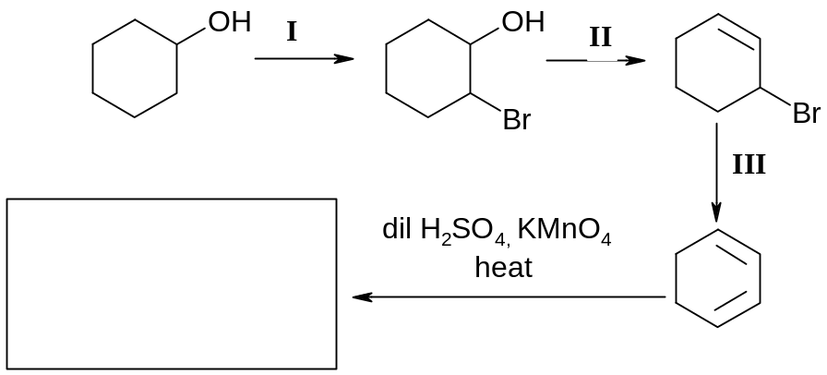  IV
 |  | (i) | What are the reagents and conditions used in Steps I, II and III?
  Step | Reagents | Conditions
  I
  II
  III
 |  | (ii) | Give the structural formula of product formed in step IV.
 |  |  |  | [4]
 |  | [Total: 8]

4 | Our bodies get energy by the digestion and metabolism of food. A combustion reaction occurs in our bodies when glucose, C₆H₁₂O₆ is burned in the presence of oxygen, carbon dioxide, water, and heat is produced. The energy released in the combustion of food molecules is converted into heat energy (to maintain our constant body temperature), mechanical energy (to move our muscles), and electrical energy (for nerve transmission). The total amount of energy released by the digestion and metabolism of food is called its calorie content.  The amount of energy in food can be measured by burning the food in a calorimeter. The temperature change produced as the water heated, the specific heat capacity of water (4.184 J/gK) or 1 calorie/gK ), and the mass of the water being heated are used to determine the amount of calories in the food.  A nutritional Calorie (Cal) is equivalent to one energy kilocalorie (kcal) or  1000 calories (cal).  A student wanted to determine the amount of calories in corn puffs by performing a calorimetric experiment as shown:  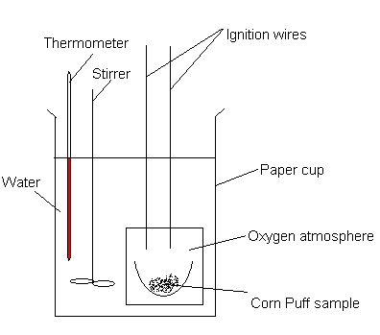  50 cm³ of water was added to the calorimeter and 0.35 g of food corn puffs was combusted. A temperature rise of 20 °C was recorded.

 | (a) | (i) | Calculate the calories absorbed by the water.

 |  | (ii) | Calculate the heat energy released by burning the corn puff.
 |  | (iii) | Calculate the calories per gram of corn puff.
 |  | (iv) | Convert calories per gram of food to nutritional Calories/ gram of food (Cal/g).
 |  | (v) | According to the nutritional information of the package of corn puff, how does the nutritional Calories (Cal) compare with the student’s experimental data?

 |  | (vi) | List one possible source of error in this experiment and suggest how to overcome the error.
 |  |  |  |  | [7]
 | (b) | The structure of glucose is  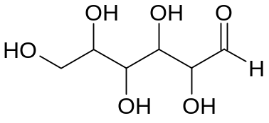
 |  | (i) | Identify the functional groups present in glucose.
 |  | (ii) | The presence of glucose can be determined by simple chemical test based on the functional groups present. Give a simple chemical test and observation expected.
 |  |  | Test:
 |  |  | Observations:
 |  | [3]
 |  | [Total: 10]

Section B
Answer two of the three questions in this section on separate paper.

5 | (a) | Hydrogen peroxide decomposes according to the equation below:  2H₂O₂ (aq) → 2H₂O (l) + O₂ (g)  Hydrogen peroxide can also be oxidised to oxygen by potassium manganate(VII).
5 | (a) | (i) | What is the oxidation state of oxygen in hydrogen peroxide?
 |  | (ii) | What volume of acidified potassium manganate(VII) of concentration 0.0200 mol dm⁻³ is decolourised by 50 cm³ of hydrogen peroxide of concentration 0.0100 mol dm⁻³?
 |  | (iii) | What volume of oxygen is evolved at room temperature and pressure in this titration?
 |  |  |  | [5]
 | (b) | The sketch below shows the first five ionisation energy for phosphorus.  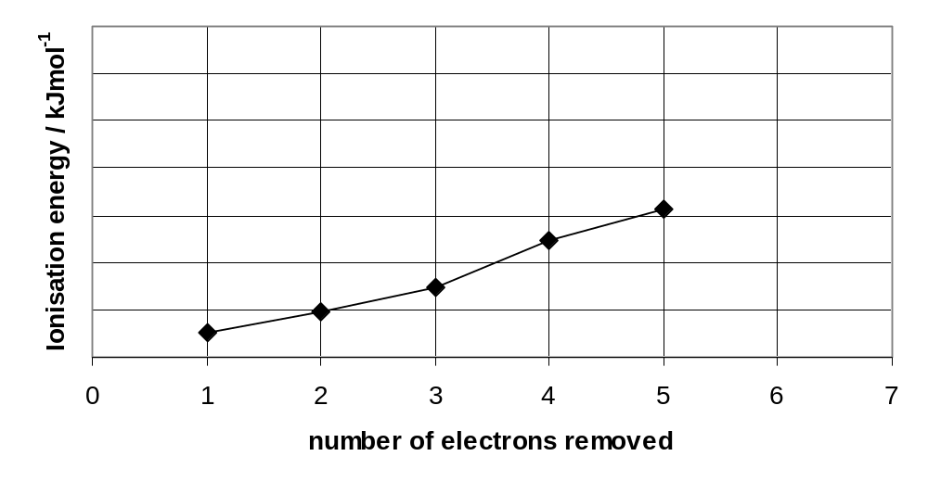
 |  | (i) | Write the electronic configuration of phosphorus in the ground state.
 |  | (ii) | Write an equation to represent the second ionisation of phosphorus.
 |  | (iii) | On the sketch above, draw an “X” to indicate a value for the  6th ionisation energy of phosphorus.
 |  | (iv) | Explain briefly why the fourth ionisation energy of phosphorus is higher than expected compared to the third ionisation energy.
 |  |  |  | [5]
 | (c) | (i) | Draw dot and cross diagrams of NO and ClO₂ and state the shape of ClO₂ drawn.
 |  | (ii) | The boiling points of chlorine dioxide and chlorine are 11 ºC and –34 ºC respectively. Explain the difference in their boiling points.
 |  |  |  | [6]
 | (d) | The melting points of magnesium chloride and silicon tetrachloride are as follows:
  compound | melting point / ºC
  MgCl₂ | 714
  SiCl₄ | −70
 |  | (i) | Briefly relate these melting points to the structure and bonding in each of these chlorides.
 |  | (ii) | The lattice energy of sodium oxide is –2000 kJ mol⁻¹.  Explain how you would expect the magnitude of the lattice energy of sodium sulphide, Na₂S, to compare with that of sodium oxide, Na₂O.
 |  |  |  | [4]
 |  |  | [Total: 20]

6 | Hydrogen sulfide is produced when thioacetamide undergoes acidic hydrolysis. The reaction is as shown:  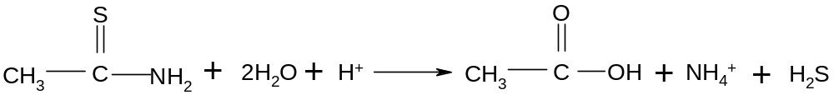
 | (a) | A series of experiments were carried out to investigate the kinetics of the reaction. The following results were obtained.
  Experiment | Initial concentration of reactant |  | Initial rate of formation of H₂S  mol dm⁻³ s⁻¹
  Experiment | Thioacetamide,  mol dm⁻³ | H⁺,  mol dm⁻³ | Initial rate of formation of H₂S  mol dm⁻³ s⁻¹
  1 | 0.240 | 0.480 | 8.0
  2 | 0.240 | 0.120 | 2.0
  3 | 0.360 | 0.240 | 9.0
  4 | 0.120 | 0.120 | 0.5
  5 | 0.240 | 0.060 | 1.0
  6 | 0.014 | 1.350 | a
 | (a) | Use the data given in the table above to find the
 | (a) | (i) | rate equation.
 |  | (ii) | rate constant, stating its units.
 |  | (iii) | value of initial rate, a for experiment 6. | [6]
 | (b) | Using collision theory, explain the effect of adding water on the rate and rate constant of the reaction in (a).
 |  |  |  | [3]
 | (c) | With the aid of a suitable diagram, explain why an increase in temperature causes an increase in rate of formation of H₂S.
 |  |  |  | [3]

 | (d) | One use of hydrogen sulfide is to produce sulfur and sulfur dioxide. The latter dissolves in water readily to form an acidic solution.
 |  | (i) | Write an equation for sulfur dioxide in water.
 |  | (ii) | Given that the concentration of H⁺ ion is 3.98 x 10⁻³ mol dm⁻³, calculate the pH of the acidic solution.
 |  |  |  |  | [2]
 | (e) | One of the side products of this reaction is ethanoic acid. When equal amounts of sodium ethanoate and ethanoic acid are mixed, an acidic buffer solution is obtained.
 |  | (i) |  | Explain what is meant by the term buffer solution.
 |  | (ii) | With the aid of equations, describe how the acidic buffer solution works as a buffer.
 |  |  |  |  | [3]
 | (f) | Ethanoic acid is a weak acid. Sodium hydroxide can be titrated with aqueous ethanoic acid or with aqueous hydrochloric acid. Which indicators from the table below could you use for each of the two titrations. Explain your answers.
  Indicator | pH range of colour change
  Methyl orange | 3.2 – 4.4
  Bromophenol blue | 2.8 – 4.6
  Phenolphthalein | 8.2 – 10.0
 |  |  |  |  | [3]
 |  |  | [Total: 20]

7 | This question concerns the preparation of an organic compound A using the apparatus illustrated below.  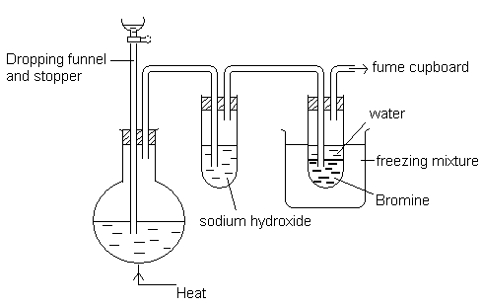  A mixture of concentrated H₂SO₄ and CH₃CH(CH₂CH₃)CH(OH)CH₃ is heated in the flask to around 170 °C. A compound B, which is the major product of the reaction, was formed and B reacted with bromine in the second test tube to form C.
 | (a) | Give the structural formula of the compound B.
 |  |  |  | [1]
 | (b) | Give the structural formula of compound C and give its IUPAC name.
 |  |  |  | [2]
 | (c) | Suggest a reason why aqueous sodium hydroxide was used in this procedure.
 |  |  |  | [1]
 | (d) | The reaction mixture in the flask developed a light brown colour, which becomes black on heating to about 170 °C. Suggest a possible identity for the black colouration.
 |  |  |  | [1]

 | (e) | State the type of reaction involved in the formation of C from B.
 |  |  | [1]

 | (f) | By structure, compound B is characterised by one functional group.
 |  | (i) | Identify the functional group.
 |  | (ii) | A herbicide, mecoprop has the following structure  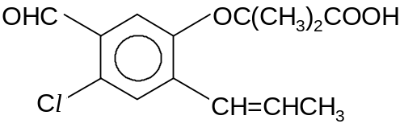  Other than the functional group identified in B; your answer in f(i), identify 2 other functional groups in the structure of mecoprop.
 |  | (iii) | State the type of stereoisomerism displayed by the structure of mecoprop. Draw the displayed formulae of the isomers. Label each isomer clearly.
 |  | (iv) | Describe two tests which can be performed on mecoprop separately to prove the presence of these two functional groups identified in f(ii).  You should include the reagents and conditions, observations and balanced equation for each test.
 |  | (v) | Draw the structure of the product formed when mecoprop reacts with
 |  |  | I PCl₅
II CH₃CH₂OH

For appreciable yield, II is carried out under a special condition. Briefly discuss this procedure.

[You may disregard the minor side-reaction involving other functional groups in mecoprop.]
 |  |  |  |  | [14]
 |  |  | [Total: 20]

